Gesture-Controlled Virtual System

**TECHNICAL FIELD OF INVENTION**

The present invention relates to the field of computer input devices and more specifically to a gesture-controlled virtual mouse. The invention provides a novel method of controlling a computer mouse through intuitive gestures made in the air, thus eliminating the need for a physical mouse. The invention employs computer vision techniques to track the user's hand movements and translates them into corresponding movements of the virtual mouse on the computer screen. The invention has potential applications in various fields, including gaming, virtual reality, and computer-aided design, where users can manipulate objects in a natural and intuitive manner.

**BACKGROUND**

Gesture-controlled virtual mouse refers to a technology that allows users to control their computers or devices by using hand gestures instead of traditional input devices such as a mouse, touchpad, or keyboard. This technology is based on the principles of computer vision and machine learning, which enable computers to recognize and interpret human gestures in real time. The concept of gesture control has been around for many years, but it has only recently become more popular and accessible due to advances in hardware and software technologies. The earliest applications of gesture control were primarily in gaming and entertainment systems, but today, the technology is being used in a wide range of applications, including healthcare, education, and productivity.  
Gesture-controlled virtual mice typically use cameras or other sensors to detect hand movements and translate them into mouse commands. The system can recognize a wide variety of gestures, including hand movements, finger movements, and even facial expressions. This allows users to control their devices more intuitively and can be especially useful for people with physical disabilities or those who prefer a more natural way of interacting with their devices. As the technology continues to improve, it is likely that gesture control will become more widespread and integrated into a variety of devices and applications. The potential benefits of this technology are numerous, including increased productivity, improved accessibility, and enhanced user experience.

**OBJECTIVES**

1. To design and implement a system that can control the mouse cursor using hand gestures and voice commands captured by a webcam.
2. To improve the human-computer interaction by reducing the need for physical contact with the computer or laptop.
3. To enable the user to perform various mouse functions such as moving, clicking, dragging, scrolling, and selecting using different hand gestures and voice assistant.
4. To use OpenCV and Python as the main tools for developing the system and processing the camera input.
5. To evaluate the performance and accuracy of the system in different scenarios and environments.

**FIGURES**

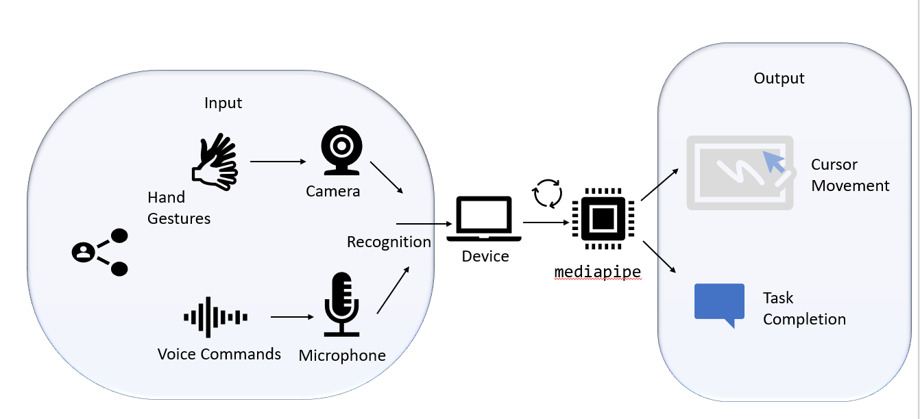

**FIG. 1 PROCESS FLOW DIAGRAM**

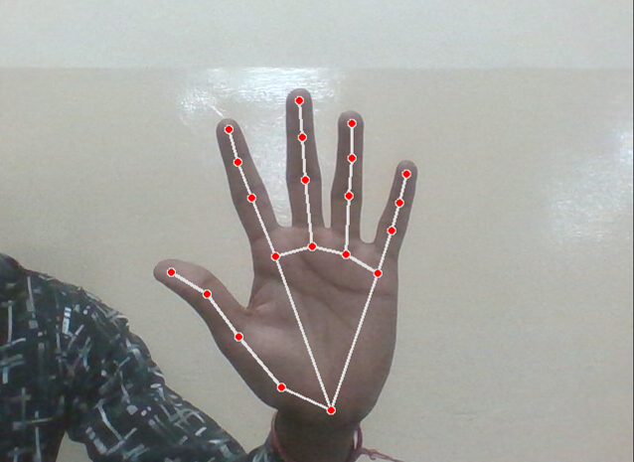

**FIG. 2 DETECTION STATE**

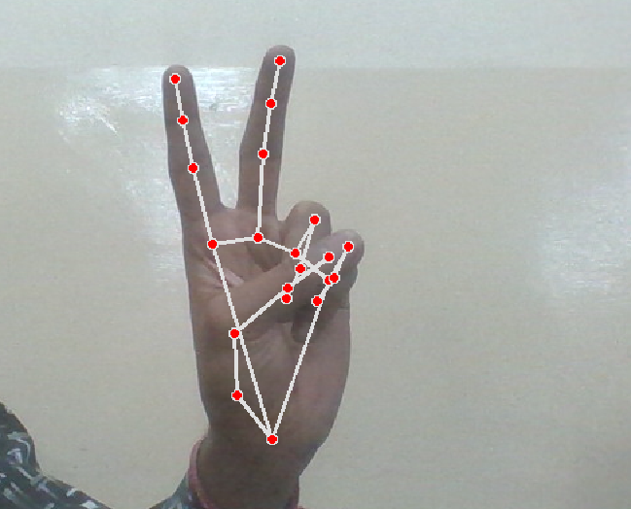

**FIG. 3 MOUSE STATE**

**CLAIMS**

* The system will have voice assistance with virtual mouse, which helps to perform mouse operation with voice commands and as well as also control the virtual mouse through our voice.
* The system will help people who are not able to interact with computer due to any physical barrier.
* This will lead to a new experience of technology to the user, and definitely it will spend more time on it.
* The system can perform all the basic required operation for the requirement as per the command initiated by the user.

**TECHNOLOGY USED**

The technology used for gesture controlled virtual mouse is based on computer vision and machine learning algorithms that can process the images captured by a webcam or a built-in camera and recognize the hand gestures and hand tip movements of the user. The system uses OpenCV and Python as the main tools for developing the system and processing the camera input. The system also uses deep learning for detecting the hands and K-cosine algorithm for detecting the fingertip location. The system then maps the fingertip location to the screen coordinates and controls the mouse cursor and functions such as moving, clicking, dragging, scrolling, and selecting

**ABSTRACT**

Gesture controlled virtual mouse is a system that allows the user to interact with a computer without using a physical mouse device. The system uses a webcam or a built-in camera to capture and process the images of the user’s hand gestures and hand tip movements. The system then recognizes the hand gestures and hand tip movements and performs the corresponding mouse functions such as moving, clicking, dragging, scrolling, and selecting. The system uses computer vision and machine learning algorithms to detect and track the hand gestures and hand tip movements. The system also uses deep learning for detecting the hands and K-cosine algorithm for detecting the fingertip location. The system aims to improve the human-computer interaction by reducing the need for physical contact and enabling natural and intuitive communication

**END USERS**

The end users of gesture controlled virtual mouse are people who want to interact with a computer without using a physical mouse device. They can use their hand gestures and hand tip movements to control the mouse cursor and functions on the screen. The end users of gesture controlled virtual mouse are also people who want to avoid physical contact with the computer or laptop, especially during the COVID-19 pandemic. They can use their hand gestures and hand tip movements to control the mouse cursor and functions without touching the computer or laptop1.The end users of gesture controlled virtual mouse are also people who want to improve their presentations or demonstrations by using hand gestures and hand tip movements to control the mouse cursor and functions. They can use their hand gestures and hand tip movements to navigate through slides, videos, or interactive programs without using a keyboard, mouse, or remote control

**ADVANTAGES**

1. Enhanced Accessibility: Gesture-controlled virtual mouse technology can help people with physical disabilities to control their computers with ease, especially those who may have difficulty using traditional mouse or keyboard devices.  
  
2. Greater Precision: With a gesture-controlled virtual mouse, users can achieve greater precision and accuracy in their movements, which can be particularly useful in tasks that require fine motor skills like video editing, gaming, or graphic design..  
  
3. No physical contact: Since the virtual mouse is controlled by hand gestures, there is no need to physically touch a mouse or keyboard, which can help to reduce the spread of germs and bacteria in public places like libraries, schools, and offices.  
  
4. Ergonomic benefits: Gesture-controlled virtual mice can help reduce the risk of repetitive strain injury (RSI), a common ailment associated with using traditional mice or keyboards, as users can perform natural and comfortable hand gestures to control their devices.  
  
5.Improved User Experience: Gesture-controlled virtual mice can provide an immersive and intuitive user experience, which can help to enhance productivity, creativity, and overall enjoyment of using a computer.

**SUMMARY**

* Gesture-controlled virtual mouse is a technology that allows users to interact with their computer without the need for a physical mouse or touchpad. Instead, users can control the cursor and perform mouse functions using hand gestures detected by a camera or other motion-tracking device.
* This technology has potential applications in various fields such as gaming, accessibility, and productivity, and can provide a more intuitive and natural way of interacting with computers.
* However, there are still challenges to overcome in terms of accuracy, speed, and user adoption, as well as concerns related to privacy and security.
* Nevertheless, gesture-controlled virtual mouse is an exciting development in human-computer interaction that has the potential to change the way we use computers in the future.

**SUBMITTED BY** –

Mr. Pradeep Tyagi (Assistant Professor)

Ayush Kumar(2000290120053,CS 6A)

Deepanshu Singh(2000290120061 CS 6A)